March 5th, 2006
Hi
Very little this week. Only two entries in my diary and both were about runs. Went last Monday with Prem. I went for a run by myself yesterday, Saturday, instead of tomorrow as I have to go for my biopsy then. Last Monday’s run was a good one. Ran from Tai P to Lead Mine Pass then up Tai Mo Shan, down to Tai Lam Chung reservoir and on to the tunnel bus. It was only about 16 degrees and much colder on TMS where it was cold, windy and misty. At 3 hours, 24 min, it was 4 minutes faster than last year, all the 4 minutes coming off the last leg as there was not hot Sun to slow me down as there was last year. Yesterday went for a shorter run at just over 2 hours.

So, that’s about it!!
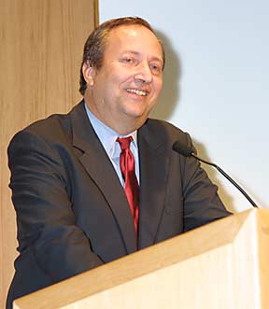
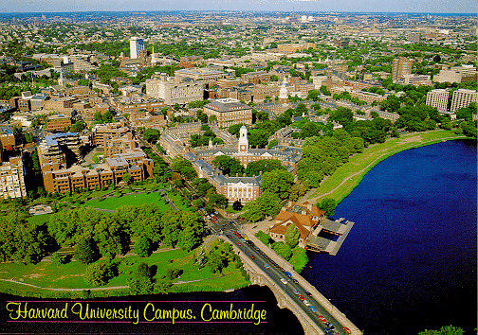
Leonie, you sent me an e-mail about the resignation of Harvard’s president. There was a one-page article in this week’s TIME magazine about it and which talked about something I have known for a long time. And this is, that in big research universities, such as Harvard and Stanford, most faculty are interested in their research and don’t care much about teaching and that undergraduate students are something they would rather not be concerned about. If I understand the article correctly, Larry Summers resigned because be could not reform undergraduate education, something he went there to do and that he learnt a lesson not to ‘mess with’ research faculty and what they want. That is why I would not recommend most undergraduate students going to such universities. For very bright students, it is OK, as they can do their study by themselves and have no need for teachers. But for the majority, good teaching and backup support (an d not just from T/As) is important. That is why good teaching universities are often preferable, though, of course, they don’t have the status of the research universities. I remember reading once that San Francisco State University was/is a very good teaching university. If you would like to read the complete article about Larry Summers, you can find it at:
Larry Summers
Harvard University
http://www.time.com/time/magazine/article/0,9171,1167762,00.html
Or, if it is not available by the time you go to the website, ask me, as I have downloaded it.
That’s about it for this time.

Cheers.

